**EPR Aufgabenblatt 5**

Bearbeiter/in: Liming Kuang – 6815480, Melanie Wester – 5613641

Gruppe: 11

Name des Tutors: Felix Lapp

Plan:

1. 11/28 – Get a better understanding of the game and determine the basic structure of the program
2. 11/29 – Finish the initiating part of the program
3. 12/01 – Finish everything except single player mode.
4. 12/02-12/07 – Single player mode
5. 12/08 – User Guide and Test

Structure of the program:

1. Initiating:
   1. Generate a chess board of 9*10
   2. User input names of 2 players, 2 players are represented by 2 colors – red and yellow
2. Game start (for single player):
   1. Start with player 1(yellow)
   2. The current player:
      1. Drop his/her disk at column i of the board
         1. Check if column i is valid for dropping a disk:
            * 1 <= i <= 10
            * The total number of disks in this column <= 9
         2. If true, drop the disk at column i
         3. If not, tell him/her to choose a new column to drop the disk
      2. Check if this player has won the game:
         1. The pattern on chess board matches one in the question.
      3. Check if the chess board is full:
         1. If every place at the first row are taken, it’s full
            * If yes, empty the chess board and restart the game
            * If not, move on
      4. Next round

User Guide:

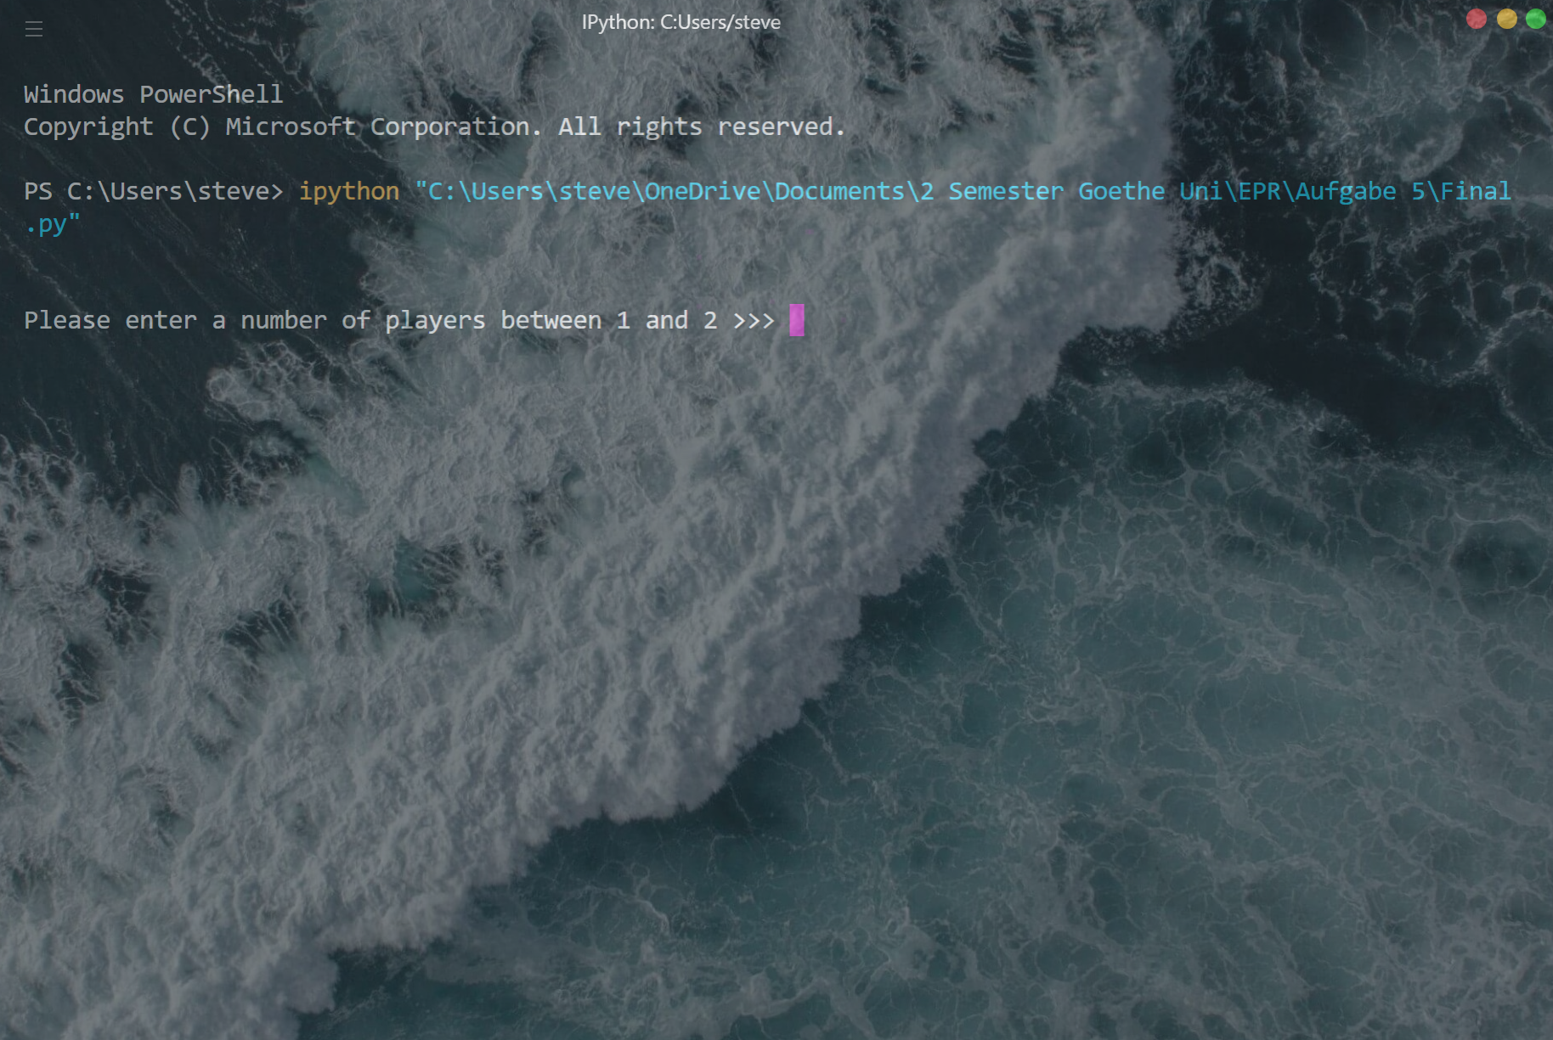

Entering the game

You could enter 1 for single player mode playing against computer or 2 for two players mode

For single player mode:



You could customize your name

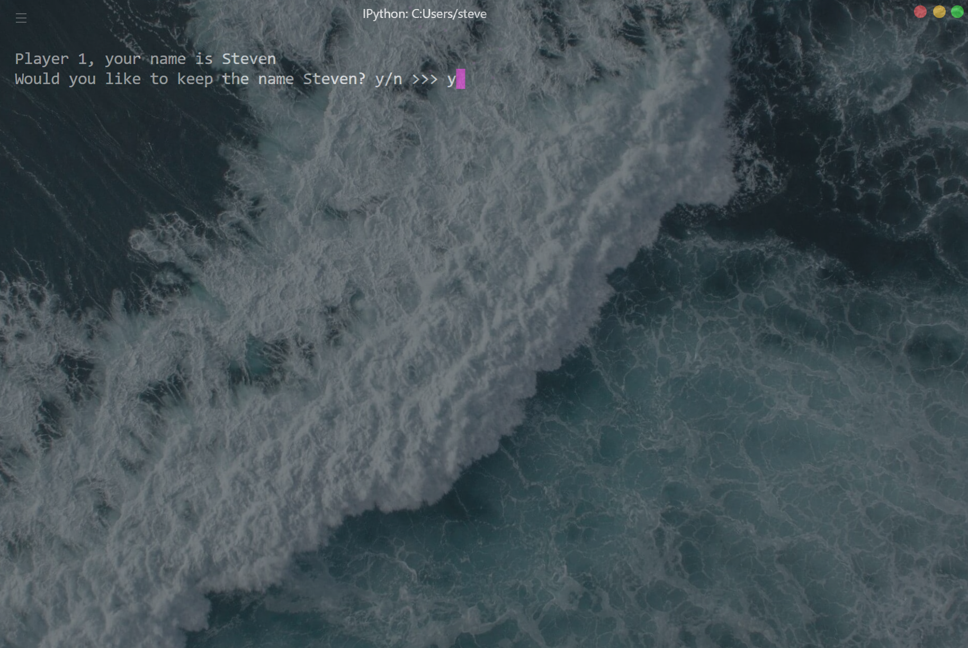

Enter y to confirm your input

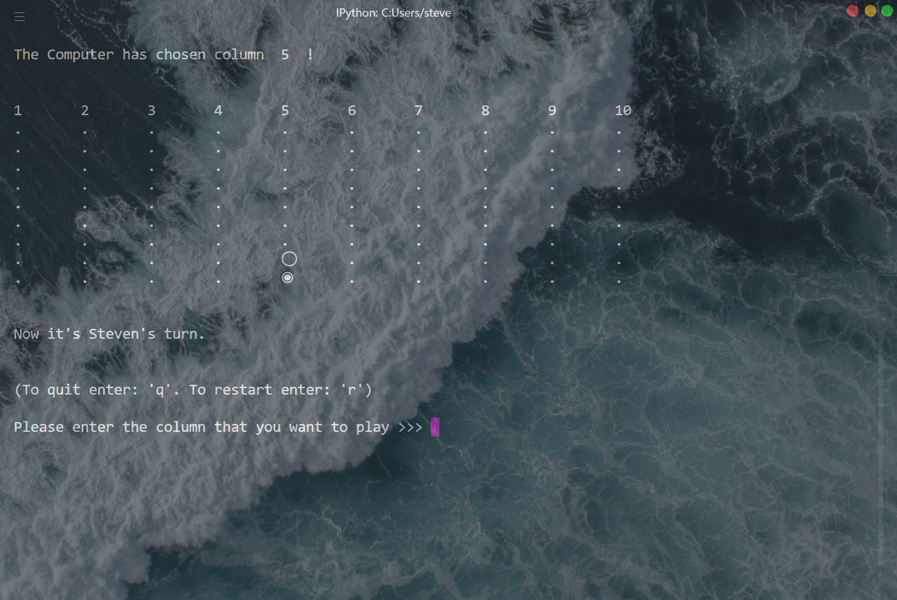

You could choose which row you want to put your next step and the computer will play next automatically.

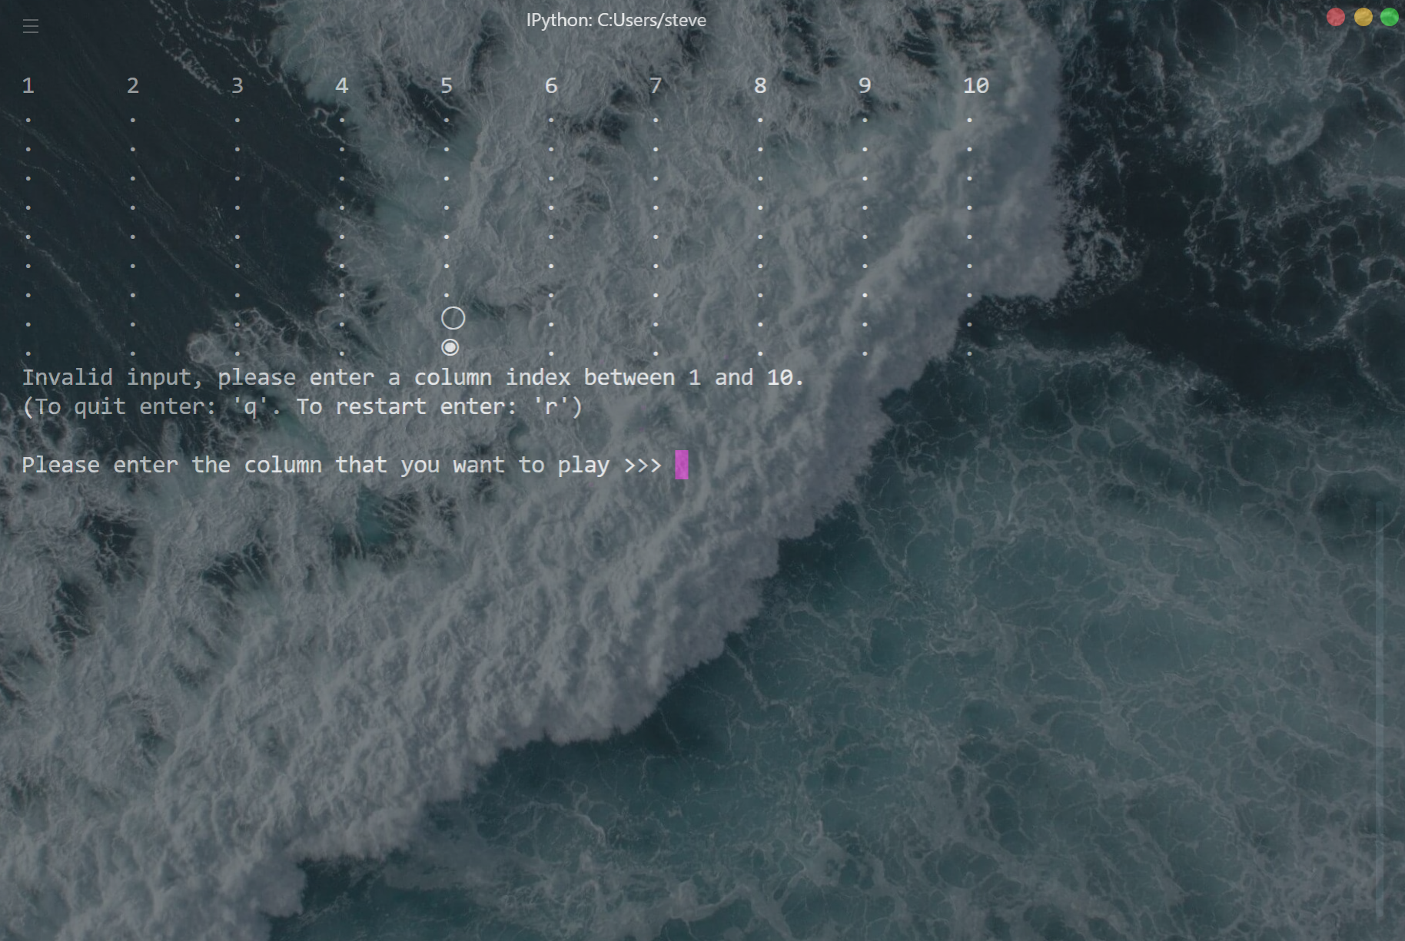

If you give an invalid input, the program will throw an error message and ask for a new input.

During the game play you always have the option to quit the game (‘q’) or restart the game (‘r’).

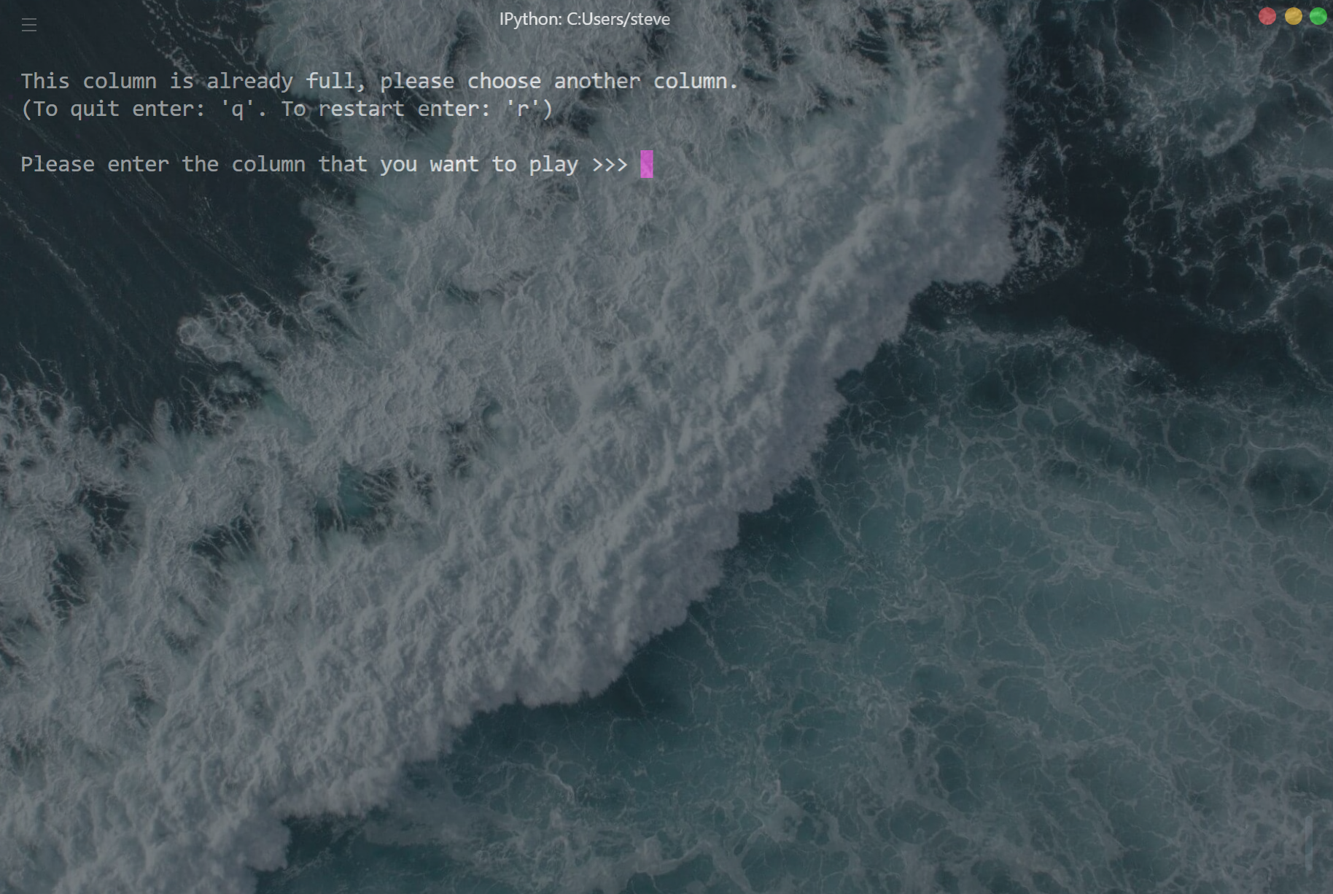

If the column is already full, this program will give an error message and ask for a new column input. And if the chess board is full, the program would tell you no one has won the game

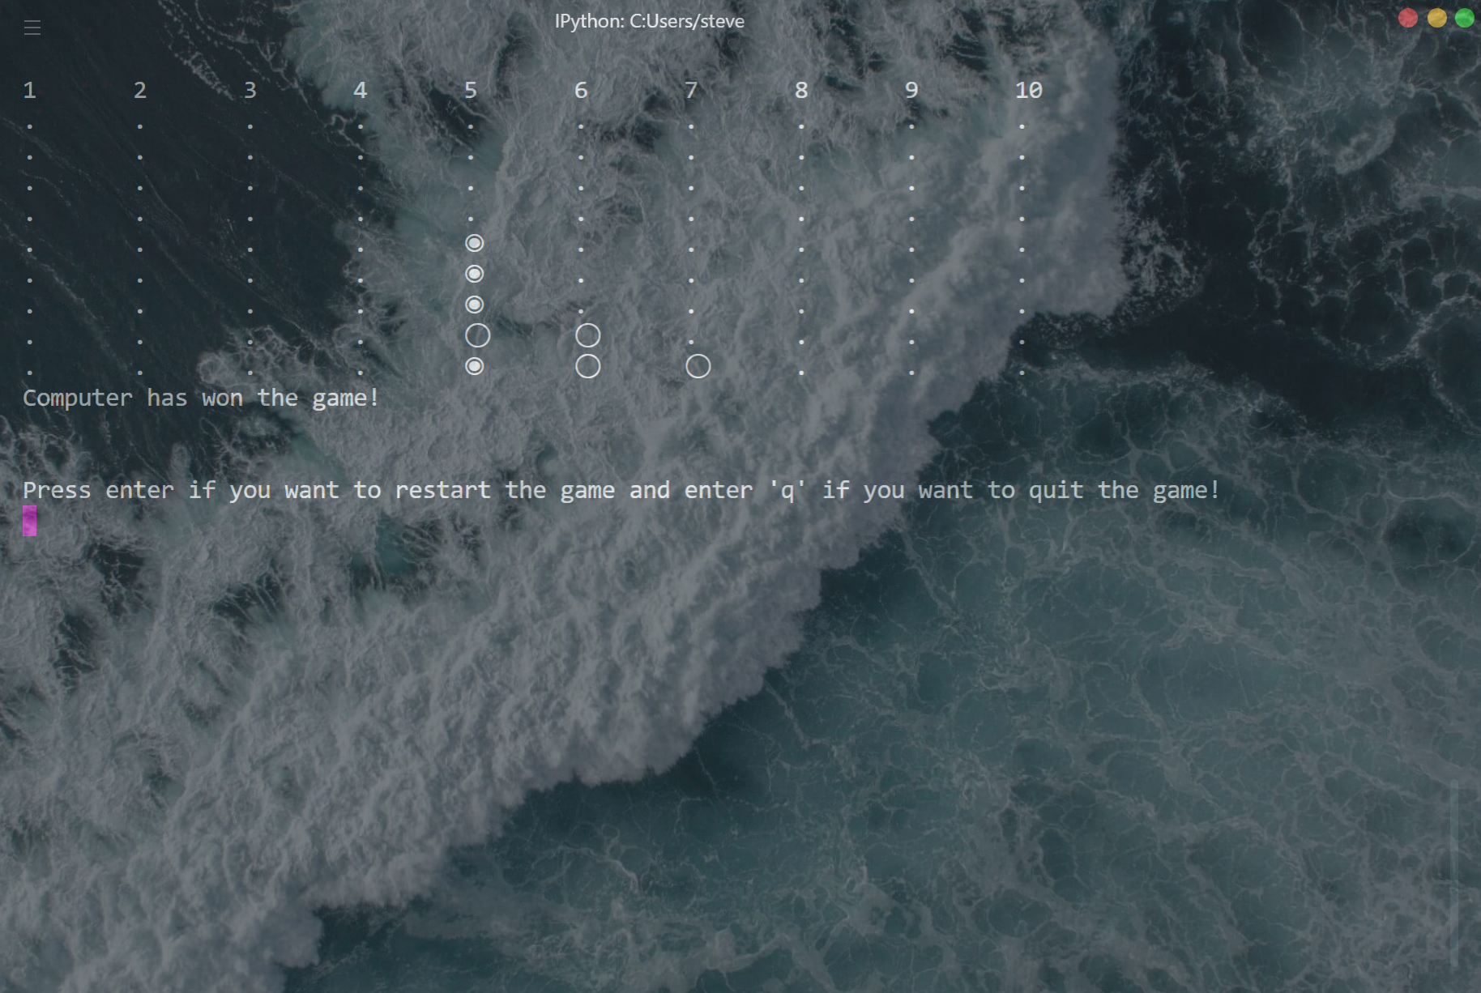

When the computer or you has a matching pattern, the program will show the player which have won the game. And ask you to press enter to start a new round or enter ‘q’ to quit the game.

For double players mode:

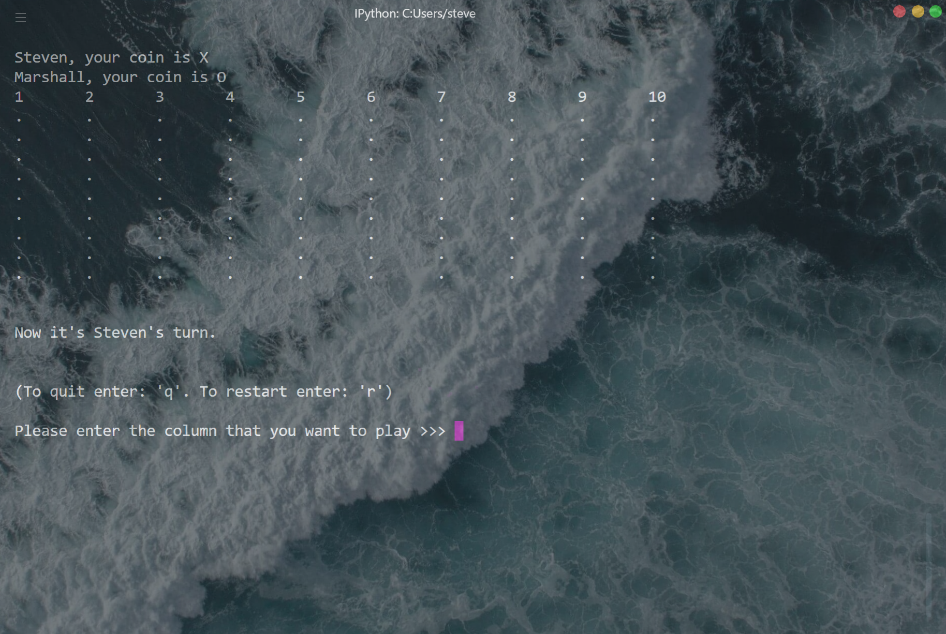

You could customize names for both players just like in single player mode.

Then you could play the game with your friend (or yourself in case you don’t have any) one after the other. Until one of you has won the game or the chess board is full. You also have the option to restart the game or quit at any time just like in single player mode.

Enjoy! 😊